**EXERCISE 3**-**STORED PROCEDURES**

**SCENARIO 1:** **ProcessMonthlyInterest**

**CREATING PROCEDURE:**

CREATE OR REPLACE PROCEDURE ProcessMonthlyInterest

IS

BEGIN

    UPDATE Accounts

    SET Balance = Balance + (Balance * 0.01)

    WHERE AccountType = 'Savings';

      COMMIT;

      DBMS_OUTPUT.PUT_LINE('Monthly interest processed successfully.');

END;

/

EXEC ProcessMonthlyInterest;

SELECT AccountID, Balance FROM Accounts;

**OUTPUT:**

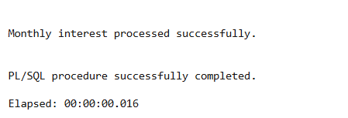

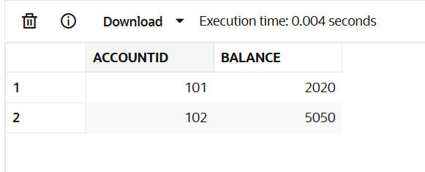

**SCENARIO 2:** **UpdateEmployeeBonus**

CREATE OR REPLACE PROCEDURE UpdateEmployeeBonus (

    p_department VARCHAR2,

    p_bonus_percent NUMBER

)

IS

BEGIN

    UPDATE Employees

    SET Salary = Salary + (Salary * p_bonus_percent / 100)

    WHERE Department = p_department;

      COMMIT;

    DBMS_OUTPUT.PUT_LINE('Bonus applied successfully to ' || p_department || ' department.');

END;

/

SET SERVEROUTPUT ON;

EXEC UpdateEmployeeBonus('HR', 5);

**OUTPUT:**

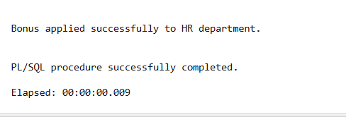

**SCENARIO 3:** **TransferFunds**

CREATE OR REPLACE PROCEDURE TransferFunds (

p_from_acc NUMBER,

p_to_acc NUMBER,

p_amount NUMBER

)

IS

v_balance NUMBER;

BEGIN

SELECT Balance INTO v_balance FROM Accounts WHERE AccountID = p_from_acc;

IF v_balance < p_amount THEN

DBMS_OUTPUT.PUT_LINE('Error: Insufficient funds.');

RETURN;

END IF;

UPDATE Accounts

SET Balance = Balance - p_amount

WHERE AccountID = p_from_acc;

UPDATE Accounts

SET Balance = Balance + p_amount

WHERE AccountID = p_to_acc;

COMMIT;

DBMS_OUTPUT.PUT_LINE('Transfer completed successfully.');

EXCEPTION

WHEN NO_DATA_FOUND THEN

DBMS_OUTPUT.PUT_LINE('Error: Account not found.');

ROLLBACK;

WHEN OTHERS THEN

DBMS_OUTPUT.PUT_LINE('Error: ' || SQLERRM);

ROLLBACK;

END;

/

SET SERVEROUTPUT ON;

EXEC TransferFunds(101, 102, 1000);

**OUTPUT:**



